ICS3UI Final Test REVIEW QUESTIONS

These are the instructions you’ll see on the Final Test

* Save this file in your *Handin* foldernow. Do not change the name of the file.
* You may not use the Internet in any way.
* You may not open any application or any saved file except for this one.
* You must do Part A first, then close the document, and then open Part B.
* Once you open Part B, you may not reopen Part A.
* Questions for Part A begin on the next page.
* Type your answers for Part A directly into this document in blue font.
* Note:   
  To get rid of the red underlining in the Python code below, turn off   
  Word’s spell-checker by following these steps:
  + Click the ***File*** tab, and then click ***Options***
  + Click ***Proofing***
  + Uncheck the box ***Check spelling as you type***
  + Uncheck the box ***Mark grammar as you type***

Use the Euclidean algorithm to find the GCD of each pair of integers. Show all your steps:

* 42 and 30
* 29 and 6
* 18 and 3
* 7 and 7

Explain why this Python program will not produce any output when it is run.

|  |
| --- |
| **def myFunction(** a **):**  **return** sqrt(a)  **def printGoodAdvice**( ):  **print**( “You should exercise for 20 minutes a day…unless you are very busy. Then you should exercise for 1 hour a day.”) |

Explain the benefits of designing software on paper before beginning to code.

|  |
| --- |
|  |

In a paragraph of 50-75 words, give three things you can do to fight the problem of e-waste.

|  |
| --- |
|  |

Write one line of Python code that prints the first element of an array named *dailyTemperatures*.

|  |
| --- |
|  |

Write one line of Python code that sets the variable z to the 3rd y-value of this array of ordered pairs:

myPoints = [[3, -5], [2, 7], [0, -2], [8, 1], [10, 0]]

|  |
| --- |
|  |

Write the output of this program.

**for** a in **range**(1,5):

**for** b in **range** (1,5):

**print**("a is now " + **str**(a) + " and b is now " + **str** (b))

|  |
| --- |
|  |

Write the output of this program in the right half of the box below. ( ___ / 4 )

|  |  |
| --- | --- |
| **def myFunction**( x ):  **return** 2*x  **def yourFunction**( a, b ):  **return** a - b  s = myFunction( 10 )  **print**( s )    t = myFunction( 30 )  **print**( t )    u = yourFunction( s, t )  **print**( z ) | **Output** |
|  |

Python programming exercises

Write a short Python program that uses a for-loop to draw 500 random stars of random sizes.

Write a Python program that lets the user enter their full name with a middle initial  
 (like “John A. Macdonald”) and prints out on 3 separate lines the first name, the middle initial without the dot, and the last name, like this:

John

A

Macdonald

Hint: Make use of the .index() function and the : operator inside square brackets.

Write a Python function named getDistance that takes four arguments x1, y1, x2 and y2 and returns the distance between the points (x1, y1) and (x2, y2). Test your function with the line

**print** ( getDistance(0, 10, 5, 6) ) #should print 6.403

Write a Python function named getMaxValue that takes an array as its argument and returns the maximum value in the array. Test your function by adding this line to the bottom of your program:

myMarks = [68, 75, 93, 90, 55, 79]

**print**( getMaxValue( myMarks )) #should print 93

Write a Python function named countEvens that takes an array of integers as its argument and returns the number of elements that are even. Test your function by adding this line to the bottom of your program:

myDieRolls = [ 4, 11, 7, 8, 12, 6, 5, 9]

**print**( countEvens( myDieRolls )) #should print 4

Write a Pyton program that uses two separate for-loops to draw this picture:

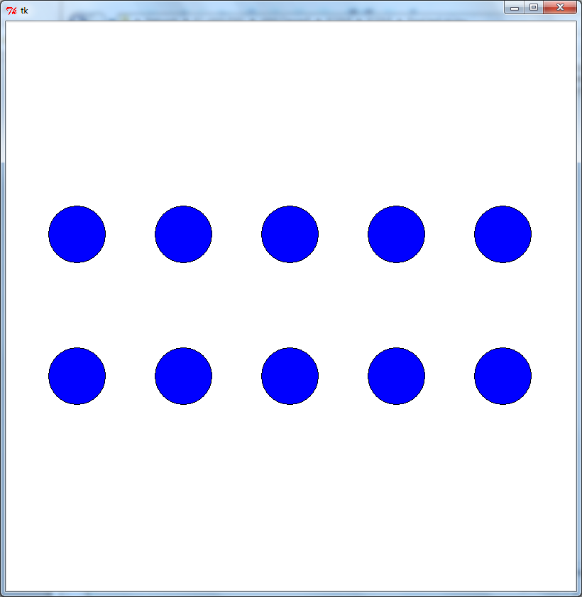

Add a nested for-loop to the above so that it draws a string from every ball in the top row to every ball in the bottom row.

